DBS311NEE L08 Answers and outputs

**Name: Wei-Chih Kao  
ID: 158000190  
Date: Dec. 02. 2021**

Task1  
Write an update statement to add new fields program and term to all documents in the students collection and set them to values “CPA” and 1.

> db.students.updateMany({}, {$set : {"program" : "CPA", "term" : 1}})

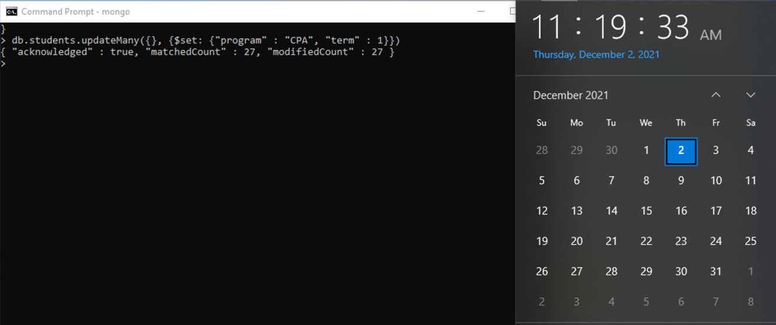

Task2  
Write an update statement to modify the value of the program field to “BTM” for all documents in the students collection.

> db.students.updateMany({}, {$set: {"program" : "BTM"}})

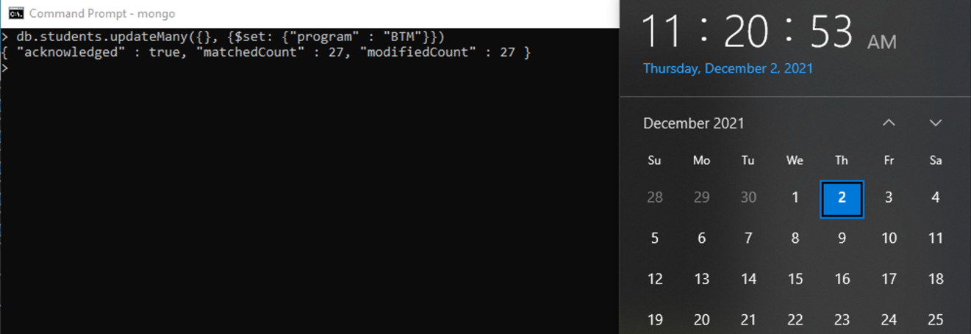

Task3  
Write an update statement to modify the value of the program field to “CPA” for the student named Jonie Raby.

Before executing an update statement or a delete statement, you can use the find() method with the update or delete criteria, to see how many documents will be affected. Write the update statement in the box below.

> db.students.find({"name" : "Jonie Raby"})  
  
> db.students.updateMany({"name": "Jonie Raby"}, {$set: {"program" : "CPA"}})

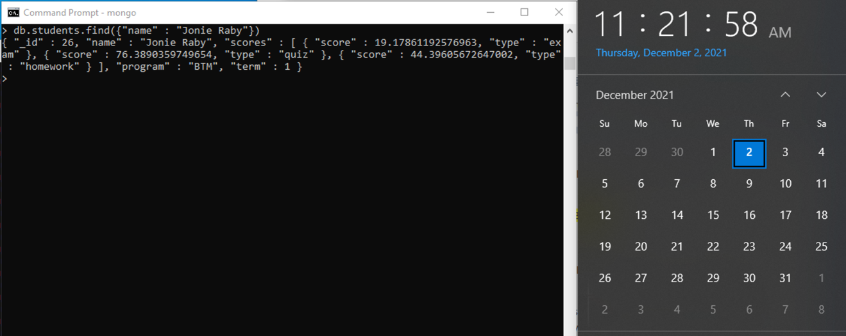

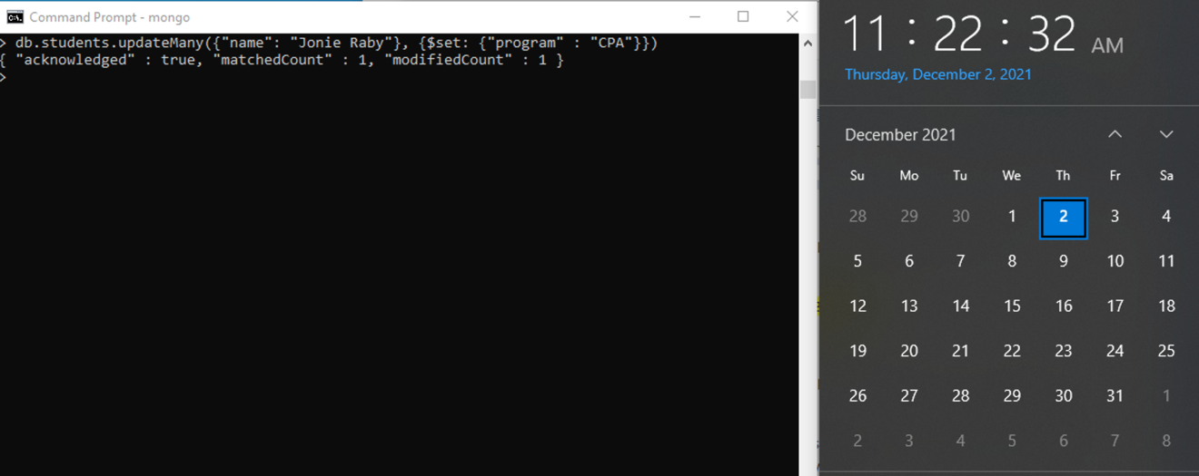

How many documents are there with the value Jonie Raby for the name field? 1

How many documents were updated? 1

Task4  
Write a query to show only the program field for the document that the value of the filed name is Jonie Raby.

> db.students.find({"name" : "Jonie Raby"}, {"program" : 1, "_id" : 0})

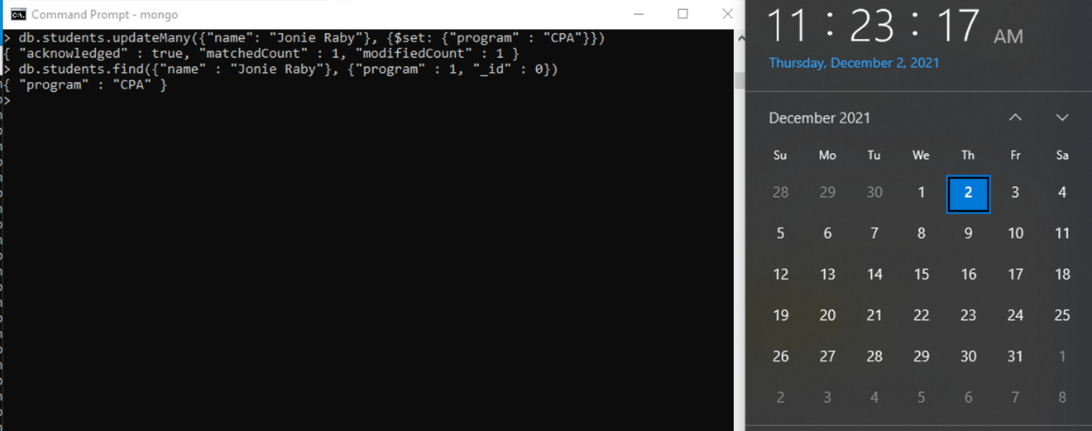

Task5  
Write an update statement to increase the value of the term field by 2 for documents with _id 20, 22, and 24.

> db.students.updateMany({"_id":{$in:[20,22,24]}}, {$inc:{"term":2}})  
  
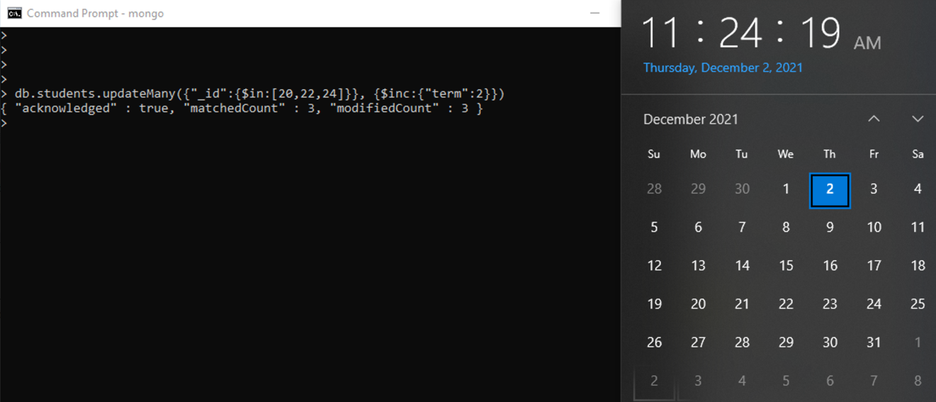

Task6  
Write an update statement to remove the term field from documents that the value of the term filed is 3.

> db.students.updateMany({"term" : 3}, {$unset : {"term" : 1}})

